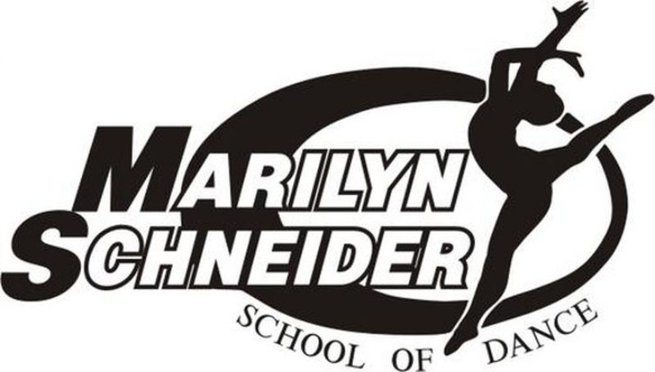 

**Welcome to all our returning and new dance families. I hope everyone had a great vacation, enjoyed the sunshine, and remained healthy during the summer months. It has been an exciting summer for MSSOD. It started with a fantastic recital. I was so proud of every dancer who stepped out on that stage.**

**Thanks for making MSSOD your dance home. Our focus is on our students and their families and putting the joy of dance in their lives. We’ve been doing this for many years and appreciate the opportunities to be part of your life and look forward to seeing you soon.**

# The magic of dance awaits you…

**Follow us!**

**Facebook:** Marilyn Schneider School of Dance

**MSSOD (private group for studio families)**

**Instagram:** mssod585

518 Long Pond Rd. Rochester, NY 14612

(585) 227-1111

We invite you to discover the Marilyn Schneider philosophy: A strong commitment to artistic integrity taught in a positive, nurturing atmosphere.

If you want to dance for fun, for development and fitness, or for professional work—look no further! Whatever your goals, we can help you achieve them and dance your way to a happy body and a healthier life. I want to thank each and every one of you for your continuous support.

Put on your dancing shoes and let’s dance!

Studio Opening **Monday, September 11, 2023**

*September 2023*

Welcome Dancers!

We ***LOVE*** seeing our dancers put in extra work during the summer to strengthen their dance technique and education.

This summer **Natasha**, **Adriana** and **Korrie** attended 7 days of dance classes while at DMA in Atlanta.

**Danielle** attended NYCDA workshops in NYC, **Samantha** attended a Ballet Intensive, **Nick** attended a week of pre-Professional classes at Steps on Broadway

and **Madi**, **Ella** and **Jayden** attended Theater Camp at OFC.

**Katie** and **Nick Wawrzaszek** taught Master Classes in Tap and Jazz for all interested MSSOD dancers.

Dancers always show much growth through these experiences. We will offer a few master classes throughout the year. **If you are interested, be sure to check the lobby bulletin board regularly.**

***Dance develops balance and coordination as well as self confidence in children. Dance builds strong, fit bodies. Dance challenges children to work hard and achieve their goals. You are a great parent for giving your child dance! We are proud of what DANCE and our studio can do for your children.***

### Dance Education Series

“There is no substitute for hard work. There will be disappointments, but the harder you work, the “luckier” you will be.”

Remember…

If you refer a friend, and they sign up for classes, to tell them to put your name as a referral on the registration form.

You will get $10 for each friend that puts your name down. What a great way to earn back some tuition!

**Dance Masters of America**

**Fall Workshop**

DMA Chapter #8 is happy to offer “in person” workshops this year.

The first workshop is scheduled for October 15th at Dance Spectrum in Buffalo, NY.

The second workshop will be held November 19th in Cicero, NY at CMC Dance Company.

Students, Level 2 and up, who would like to participate can sign up in the dance studio lobby.

This is a great way for your child to be exposed to the fun and exciting world of dance conventions, as well as study from top instructors and choreographers of the dance industry.

**All dancers are invited to participate in one or both workshops.**

**Helpful tip:**

Ballet shoes should be worn snugly with all ties tucked in at all times.

It’s not too late to add a class! Call the office at 227-1111 for available classes or register online at [www.msschoolofdance.com](http://www.msschoolofdance.com)

**$10**

**Referral Bonus Special!**

For the first time (and maybe last) time ever there was a tie for the most deserving student to receive this prestigious award. My 2023 winners are **Kiera Oppelt** and **Nathan Litz**. They both exemplify the many wonderful character traits of Christal. Both Kiera and Nathan are kind, responsible, dependable, and wonderful role models to all!

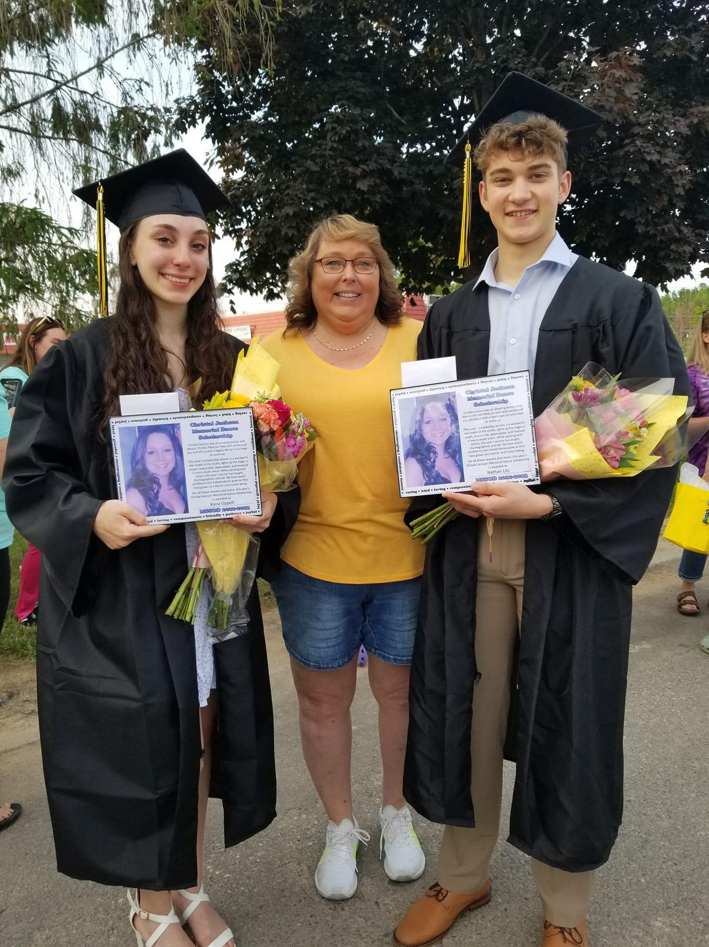

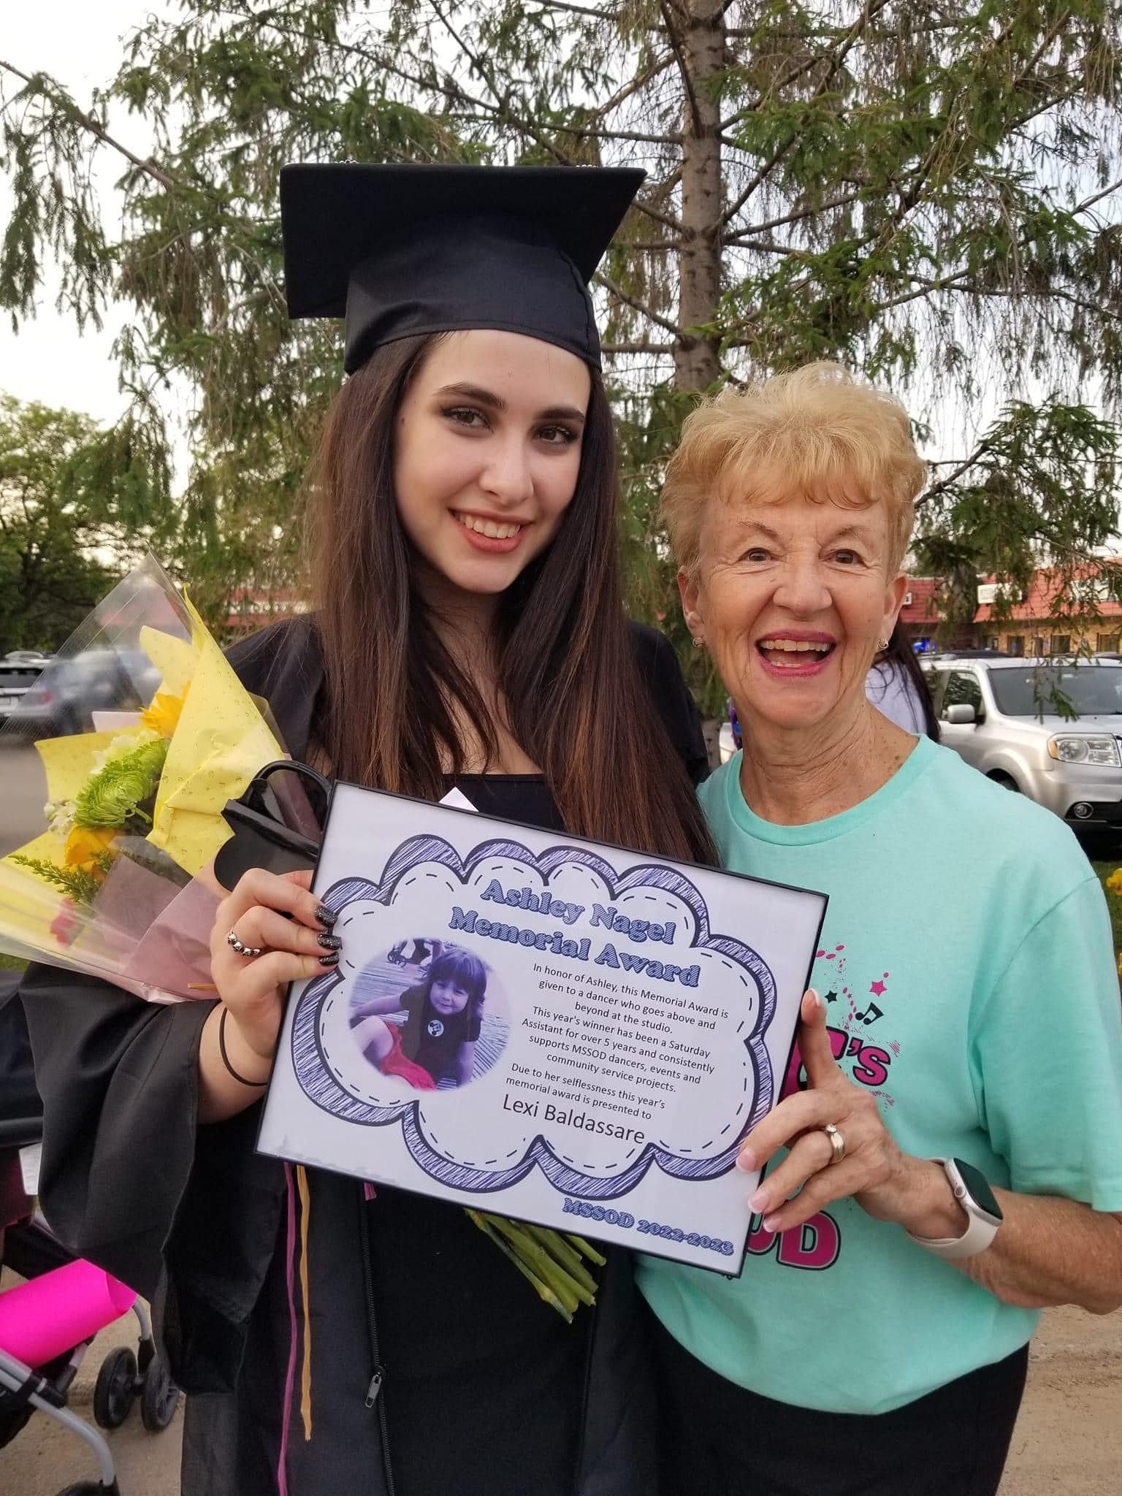

***Introducing…*** Korrie Kaufman, Aria Lekich and Rebecca Stibol

Our 2023 recipient of the Ashley Nagel Scholarship is **Lexi Baldassare**. This award is based on MSSOD community service, kindness to all and being a role model to all MSSOD dancers. Lexi was a perfect choice for this year’s award. Congratulations Lexi!

**2023 Ashley Nagel**

**Scholarship Winner**

***Introducing…*** Arya Fien, Hadley Gallagher, Daniella Jones, Isabella Nettnin and Armani Scott and Aria Lekich

**2023-2024 Pee Wee Team**

**2023-2024 Rising Star House Company Team**

***Introducing…***Madilyn Boura, Natasha Casey-Holowka, Sophia Casey-Holowka, Tatiana Casey-Holowka, Grace DiCataldo, Olivia Falkner, Brianna Fella, Nicholas Guarino, Averie Mangiavellano, Ella Merica, Ana Morrison, Samantha Moscato, Sarah Moscato, Adriana Persica and Danielle Sapor.

**2023 Christal Jackson**

**Memorial Fund Winner**

**2023-2024 Elite Travel Company Team**

Dancer News

To celebrate and learn about the Olympics, our summer acro students held a mini Olympics.

Each student choreographed a two-minute routine.

***Gold Medals***

Aria Lekich, Nicholas Guarino

***Silver Medals***

Danielle Sapor, Brianna Fella

***Bronze Medals***

Sam Muscato, Korrie Kaufman

Congrats to everyone who competed, you are all winners for trying!

Acro Olympics

2023

In August, MSSOD held a choreography contest where dancers choreographed and performed their winning routines. I was so very proud of all of the dancers who participated and hope that next year we will have more brave dancers ready to strut their stuff. Dancers presented lyrical, tap, ballet, jazz, and contemporary routines.

First place solo Jr. Division was awarded to **Korrie Kaufman**. Second place went to **Aria Lekich**. Third place went to **Grace Dicataldo**.

In 13 and over solo category first place went to **Nick Guarino.** In the 13 and over Duet category a first place was awarded to **Tatiana Casey-Holowka** and **Olivia Falkner**.

Congratulations to all, great job!

Budding Choreographers

***2023 Bernard and Ethelyn Schneider Memorial Award***

**Our winners of the Bernard and Ethelyn Schneider Memorial Scholarship Award are Kim Muscato**

**and her family – Samantha and Sarah. This award**

**is based on *LOYALTY* to MSSOD. Kim and her**

**girls are very deserving recipients. They are**

**loyal, kind, and helpful and all at MSSOD and**

**have been for many years.**

**CONGRATULATIONS!**

Cont.

**Ballet** *Armani Scott*

**Tap** *Ella Merica*

**Jazz** *Korrie Kaufman*

**Hip-Hop** *Aria Lekich*

**Acro** *Sami Urban*

**Lyrical/Contemporary** *Tatiana Casey-Holowka*

**Musical Theatre** *Danielle Sapor*

Most Improved Awards

**BUDDING CHOREOGRAPHERS**

In August, MSSOD held a choreography contest were dancers choreographed and performed their winning routines. I was so very proud of all the dancers who participated and hope that next year we will have more brave dancers ready to strut their stuff. Dancers presented lyrical, tap, ballet, jazz and contemporary routines.

First place solo Jr. Division was awarded to Korrie Kaufman, second place went to Aria Lekich. Third place went to Grace DiCataldo.

In 13 and over solo category first place went to Nick Guarino. In the 13 and over duet category a first place was awarded to Tatiana Casey-Holowka and Olivia Falkner.

Congratulations to all, great job!

Class Parties

If you are planning to bring anything for class to enjoy birthdays, holidays, etc., please keep it simple and check ingredients as some of our dancers have food allergies.

**BRING A FRIEND WEEK September 25th-30th**

Dancers are invited to bring a dance friend of approximately the same age to class September 25th-30th. Friends will be encouraged to participate and have some dance fun. There is an invitation in your dancer’s mailbox. Please make sure to bring it to class filled out. It’s a fun time for all!

Tuition Payment Policy

Tuition is based on a yearly fee but is divided into 10 equal payments for your convenience.

Please note, due to holidays and the calendar not having the same number of days each month, your monthly class frequency will **not** always be the same.

Payments are due at the first class of each month; we do not send bills. Please pay your tuition by the 10th of each month to avoid a late fee. **A $10 late fee will be added to your acct on the 15th of the month if you fail to pay on time.**

Class Attire

*As stated in our brochure, students are required to adhere to our dress code:*

**Ballet & Lyrical-** leotard, tights,

skirt or dance shorts

**Tap, Jazz, Contemporary, Improv & Musical Theatre-** leotards and dance pants are allowed. Tights must be worn! **No** street clothes or street shoes are to be worn in class.

**Hip Hop-** Loose fitting clothes are allowed and shoes that are **not** to be worn outside the studio.

Please make sure your dancer arrives dressed appropriately and ready to dance.

Hair **must** be secured away from the face. Please bring your own hair ties, clips, bobby pins, etc. and leave jewelry at home.

**No gum, candy, food or drink except water is allowed inside the studio. Failure to comply with these rules will result in the student sitting out from class.**

**Helpful tip:**

Label all dance clothes and shoes with your dancer’s name, initials, or phone number.

This helps ensure that each dancer leaves with their own belongings.

***DUE TO COVID THERE IS NOT A LOST AND FOUND AT THE STUDIO***.

Our studio sells dance supplies needed for class. We have shoes, leotards, tights, shirts, shorts, etc.

A display will be set up during the month of Sept. Orders will be taken for sweatshirts, jackets, dance bags, etc.

Keep your dancer hydrated with our studio water bottles for only $3 each. ***\*\*Only water is allowed in the studio for dancers.***

You can order MSSOD Dance apparel and accessories on our website. These make great gifts for dancers!

We offer a wide range of classes from introductory classes for beginners to company level classes for the serious dancers.

In between, you’ll find a full selection of intermediate and recreational classes to fulfill the needs of any student.

We offer adult classes as well! Contact us if you are interested.

Transfer Students

Thank you for choosing MSSOD as your new dance studio. We are proud to have you and want very much to help you feel at home in your new classes.

As transfer students come from all over the country, it may take a few trial classes to find the best placement for each dancer. We ask that you are patient and welcoming as we find the right fit for everyone.

Record Update

We are in the process of updating all our files.

**Please fill out a current registration form and return ASAP. Email addresses will not be given out or sold.**

Thank you.

Students are placed in classes where I feel they will be challenged, but not overwhelmed.

Students will be observed the month of Sept. and any necessary changes will be made. If a student is falling behind, we may recommend another class.

Thank you for your cooperation.

An article recently published in USA Today states that physical activity can improve not only students’ health but their academic performance as well.

A study released by the American Medical Association (AMA), found that 20 minutes of vigorous activity at least 3 days every week was needed for children to excel academically.

“Physical activity may reduce boredom and increase attention span and concentration,” Dawn Cook, lead author of this study.

“Increased activity levels may also lead to higher self-esteem and all these factors play a role in the relationship between physical activity and academic performance.”

Dance develops balance and coordination as well as self-confidence in children. Dance builds strong, fit bodies. Dance challenges children to work hard and achieve their goals.

You are a great parent for giving your child dance! We are proud of what dance and our studio can do for your children.

Academic Excellence

Class Placements

Looking ahead…